**一、头部**

1.Home/Tpl/default/Public/head.html

<span class="top_name">Welcome: <{$Think.config.web_name}></span>

换成：

<span class="top_name"><a href="mailto:<{$Think.config.web_email}>"><i class="fa fa-envelope" aria-hidden="true"></i> Email: <{$Think.config.web_email}></a></span>

邮箱小图标：<i class="fa fa-envelope" aria-hidden="true"></i>

电话小图标：<i class="fa fa-phone" aria-hidden="true"></i>

标记小图标：<i class="fa fa-paperclip" aria-hidden="true"></i>

Home小图标：<i class="fa fa-home fa-fw" aria-hidden="true" ></i>

Whatsapp:<i class="fa fa-whatsapp" aria-hidden="true" ></i>

地址小图标：<i class="fa fa-map-marker fa-fw"></i>

新闻小图标：<i class="fa fa-file-text-o" aria-hidden="true"></i>

语言栏：

<div class="top_lang">

<p class="nav_icons">

<a href="<{$Think.config.msn_account}>" target="_blank" ><i class="fa fa-facebook"></i></a>

<a href="<{$Think.config.alibaba_account}>" target="_blank" ><i class="fa fa-twitter"></i></a>

<a href="<{$Think.config.msn_name}>" target="_blank" ><i class="fa fa-google-plus" ></i></a>

<a href="<{$Think.config.alibaba_name}>" target="_blank"><i class="fa fa-linkedin" aria-hidden="true"></i></a>

<a href="<{$Think.config.taobao_account}>" target="_blank" ><i class="fa fa-instagram" ></i></a>

<a href="<{$Think.config.1688_account}>" target="_blank"><i class="fa fa-youtube"></i></a>

<span><a href="__ROOT__/inquiry" class="quote">Get a Free Quote</a></span>

</p>

</div>

Css样式：

在.top_name{display: inline-block; padding-top:10px;}下添加

.top_name a {border-right: 1px solid #e5e5e5;border-left: 1px solid #e5e5e5;padding: 10px;overflow: hidden;color: #666;font-size: 14px;}

.nav_icons a{display: inline-block;color:#666; border-radius: 50%;padding: 5px;}

.nav_icons i {font-size: 14px;height: 26px;width: 26px;border-radius: 50%;line-height: 26px;text-align: center;background-color:#fff;}

1. quote {background-color: #0072bc;border-radius: 10px;color: #fff;margin-left: 5px; margin-right: -10px;font-size:12px;padding: 3px;}

.top_lang{margin-top: -8px;}

.top_name{display:none;}

换成：

.top_name a{border-left: 0px; border-right: 0px; }

**二、表单**

1.Home/Tpl/default/Inquiry/index.html

删除：

<div class="form-group">

<label for="number" class="col-sm-3 control-label">Order quantity: </label>

<div class="col-sm-6">

<input type="number" name="num" class="form-control" id="number">

</div>

</div>

2.Home/Lib/Action/InquiryAction.class.php

删除：

A:$data['num'] = $this->_post('num','htmlspecialchars');

B:<p>订购数量：".$data['num']."</p>

1. Kogin/Tpl/Inquiry/(Applogin/Tpl/Inquiry/(Office/Tpl/Inquiry/))view.html

删除：

<tr class="secondalt">

<td height="25"><span style="padding-left:10px;">订购数量：</span></td>

<td><{$inquiry.num}></td>

</tr>

**三、客服面板**

具体过程和文件在“在线留言文件夹里”

1. HTML位置：Home/Lib/Widget/Online/
2. Css位置：Public/css/
3. JS位置：Public/js/
4. 图片位置：Public/images/

**四、底部Whatsapp**

1.Kogin（Applogin）/Tpl/Config/index.html

手机一行换成或增加

<TD style="padding-left: 5px;"><SPAN>Whatsapp</SPAN></TD>

<TD style="padding-top: 5px; padding-bottom: 5px;"><input name="web_icp" value="<{$Think.config.web_icp}>" type="text" class="FormSmall" style="width: 220px;"></TD></TR>

<TR class="secondalt">

如果有备案号一栏，直接把“备案号”换成“Whatsapp”

2.Home/Tpl/default/Public/foot.html

TEL:

<{$Think.config.web_tel}>

换成

Whatsapp:

<{$Think.config.web_icp}>

**五、亚马逊链接**

1. Home/Tpl/default/Product/index.html

在

<a href="javascript:orderform.submit();" class="btn btn-info page-btn"><span class="glyphicon glyphicon-triangle-right" aria-hidden="true"></span> INQUIRY</a>

后加

<a href="<{$product.description}>" target="_blank" class="btn btn-primary page-btn"><span class="glyphicon glyphicon-shopping-cart" aria-hidden="true" style=" padding-right: 5px;"></span>BUY NOW</a>

1. Kogin/Tpl/Product/add.html+mod.html

<td>SEO描述：</td>

换成

<td>亚马逊商城链接：</td>

1. 在后台“亚马逊商城链接：”处添加对应链接

**六、底部替换**

1.Home/Tpl/default/Public/foot.html

a、e142

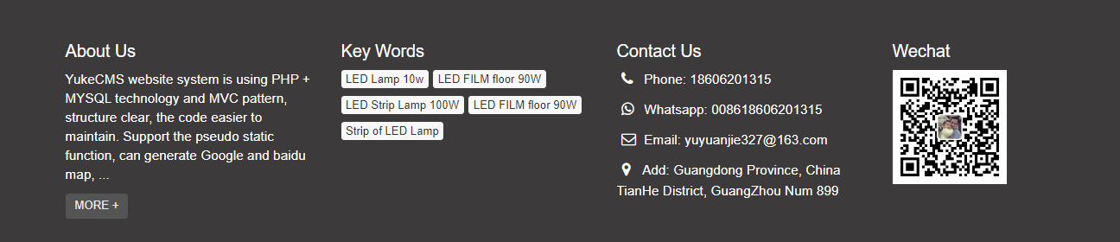

b、e28



c、e011

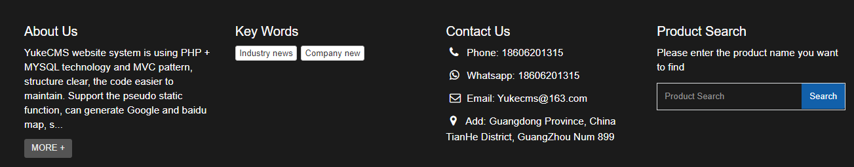

**七、底部加小图标**

1.Home/Tpl/default/Public/foot.html

<p class="foot_icons">

<a href="<{$Think.config.msn_account}>" target="_blank" ><i class="fa fa-facebook-official"></i></a>

<a href="<{$Think.config.alibaba_account}>" target="_blank" ><i class="fa fa-twitter-square"></i></a>

<a href="<{$Think.config.alibaba_name}>" target="_blank"><i class="fa fa-linkedin-square" aria-hidden="true"></i></a>

<a href="<{$Think.config.taobao_account}>" target="_blank" ><i class="fa fa-instagram" ></i></a>

<a href="<{$Think.config.1688_account}>" target="_blank"><i class="fa fa-youtube-square"></i></a>

</p>

Css：

.foot_icons a{display: inline-block;color:#fff;padding: 5px;transition: 0.5s;}

.foot_icons i {font-size: 32px;height: 32px;width: 32px;line-height: 32px;text-align: center;}

.foot_icons a:hover{color:#000;transform: translate(0px, -10px);}

**八、加搜索框（w40）**

1.Home/Tpl/default/Public/head.html例：w40

英文：

<div class="top_search">

<form id="search1form" method="get" action="<{:U('Search/index')}>" >

<div class="input-group search_group" >

<input type="text" name="name" class="form-control input-sm" placeholder="Product search" >

<span class="input-group-btn">

<span id="search_submit" onclick="searchform.submit();" title="Products search" class="glyphicon glyphicon-search btn-lg" aria-hidden="true"></span>

</span>

</div>

</form>

</div>

</div>

Css：

.top_search{float: right; width: 30%;margin:-5px 10px 0px 0px;}

.top_search .search_group{ float: right; margin: 5px 0px 0px 0px; border:1px solid #666; border-radius:20px;}

.top_search .search_group input.form-control{ border-radius: 0px; box-shadow: none; color: #000; padding: 0px 0px 0px 15px; height: 26px; background: transparent; border: none;}

.top_search .search_group input.form-control:focus{ box-shadow: none; border-color: #b2e0fb;}

#search_submit{ color:#C3C4C5; height: 26px; font-size: 16px; margin-top: -14px;}

#search_submit:hover{ color:#0067b6; cursor: pointer;}